Problem Statement:

The problem at hand is the development of an Automated Citizenship Assessment System for Masathai, a newly unified country formed by Malaysia, Singapore, and Thailand. This system aims to create a standardized Citizenship Test for all citizens, which will acquaint them with the history and culture of Masathai. The key challenge is to design and implement an efficient and user-friendly system that ensures a fair representation of questions from each of the three member countries.

Purpose of the Document:

This document serves to provide an in-depth analysis and design of the Automated Citizenship Assessment System for Masathai. It outlines the objectives, key features, and technical aspects of the system, offering a clear roadmap for its development and implementation. The document is intended for various stakeholders, including the development team, project managers, and anyone interested in understanding the system's functionality and purpose.

Key Objectives:

1. Unifying Citizenship Test: The primary objective is to create a unified Citizenship Test that introduces citizens to the history and culture of Masathai, thus fostering a sense of national identity among the citizens of Malaysia, Singapore, and Thailand.

2. Candidate Registration and Authentication: The system must enable candidates to register their details securely and authenticate them for the test. This ensures that only eligible individuals can take the test.

3. Examination Module: The system should provide a user-friendly examination module that presents questions in various formats and tracks candidate progress, ensuring a comprehensive assessment.

4. Analysis and Result Presentation: After the test, the system should analyze the results, calculate statistics, and determine whether a candidate has passed or failed. This analysis is essential for understanding the citizens' performance.

5. User Interface and Object-Oriented Principles: The system must have an aesthetically pleasing and user-friendly interface. Additionally, it should adhere to object-oriented programming principles like encapsulation, inheritance, and polymorphism for efficient and maintainable code.

6. Unique Implementation: The system should incorporate unique features that set it apart from other citizenship assessment applications, enhancing its utility and appeal.

Significance of the System:

The Automated Citizenship Assessment System for Masathai plays a pivotal role in achieving the following objectives:

- Promoting National Unity: By fostering a shared understanding of Masathai's history and culture, the system contributes to national unity and a sense of belonging among citizens from diverse backgrounds.

- Efficient Assessment: The system streamlines the citizenship assessment process, making it convenient for both candidates and administrators.

- Data-Driven Insights: The system provides detailed statistical analyses of test scores, which are invaluable for decision-makers and policymakers.

- Object-Oriented Principles: By adhering to object-oriented programming principles, the system ensures a robust, maintainable, and extensible design.

- Uniqueness and Differentiation: The inclusion of unique features sets this system apart from other citizenship assessment applications, making it a valuable tool for Masathai.

Part 2: Work Responsibilities and Delegation

In the development of the Automated Citizenship Assessment System for Masathai, it is imperative to define the roles and responsibilities of each team member to ensure a smooth and successful project. Here, we describe the specific roles and responsibilities of each team member and discuss how tasks are divided and coordinated among them.

**Table: Work Visualization**

|  |  |
| --- | --- |
| Team Member | Roles and Responsibilities |
| Abhishek | Project Manager: Oversee the entire project, including planning, development, and testing. Also, act as a developer in the project, contributing to coding tasks. |
| Arjun | Lead Developer: Lead the software development efforts, design the system architecture, and ensure code quality. |
| Gunjan | UI/UX Designer: Design the user interface for the system, create static prototypes, and ensure a user-friendly design. |
| Nishil | Database Developer: Design and implement the database schema for candidate registration, authentication, and test results. Also develop and execute test cases to ensure the system's functionality and correctness. |
| Kreetika | Database Developer: Assist Nishil in designing and implementing the database schema. As well as Develop and execute test cases to ensure the system's functionality and correctness and create/maintain project documentation. |

Roles and Responsibilities Explanation:

- Abhishek (Project Manager and Coder): Abhishek takes on a dual role as the Project Manager, responsible for overseeing the entire project, and as a coder, actively contributing to development tasks. As the Project Manager, Abhishek defines project milestones, ensures the project stays on track, and manages communication within the team and with stakeholders. In his coder role, he participates in coding tasks under the guidance of the Lead Developer.

- Arjun (Lead Developer): Arjun serves as the Lead Developer, leading the software development efforts. He plays a crucial role in designing the system architecture and ensuring the quality of the code. Arjun's responsibilities include coordinating with the other developers and working closely with the UI/UX Designer for effective integration of design elements.

- Gunjan (UI/UX Designer): Gunjan specializes in UI/UX design, ensuring the system's user interface is aesthetically pleasing and user-friendly. She creates static prototypes for various forms and screens, selects color schemes, fonts, and graphics, and collaborates with the development team to implement design elements seamlessly.

- Nishil (Database Developer and QA Tester): Nishil takes on the role of the Database Developer, responsible for designing and implementing the database schema. Additionally, he assumes the role of a QA Tester, where he develops and executes test cases to ensure the system's functionality and correctness.

- Kreetika (Database Developer, QA Tester, and Documentation Specialist): Kreetika assists Nishil in designing and implementing the database schema as a Database Developer. She also shares responsibilities with Nishil as a QA Tester, focusing on testing the system's functionality and correctness. Furthermore, Kreetika plays the role of a Documentation Specialist, creating and maintaining project documentation, including system requirements, design documents, and user manuals.

This distribution of roles and responsibilities ensures that each team member has a defined and complementary role within the project, promoting collaboration and efficient task execution.

- Responsibilities:

- Develop and execute test cases to ensure the system's functionality and correctness (QA Tester).

- Create and maintain project documentation, including system requirements, design documents, and user manuals (Documentation Specialist).

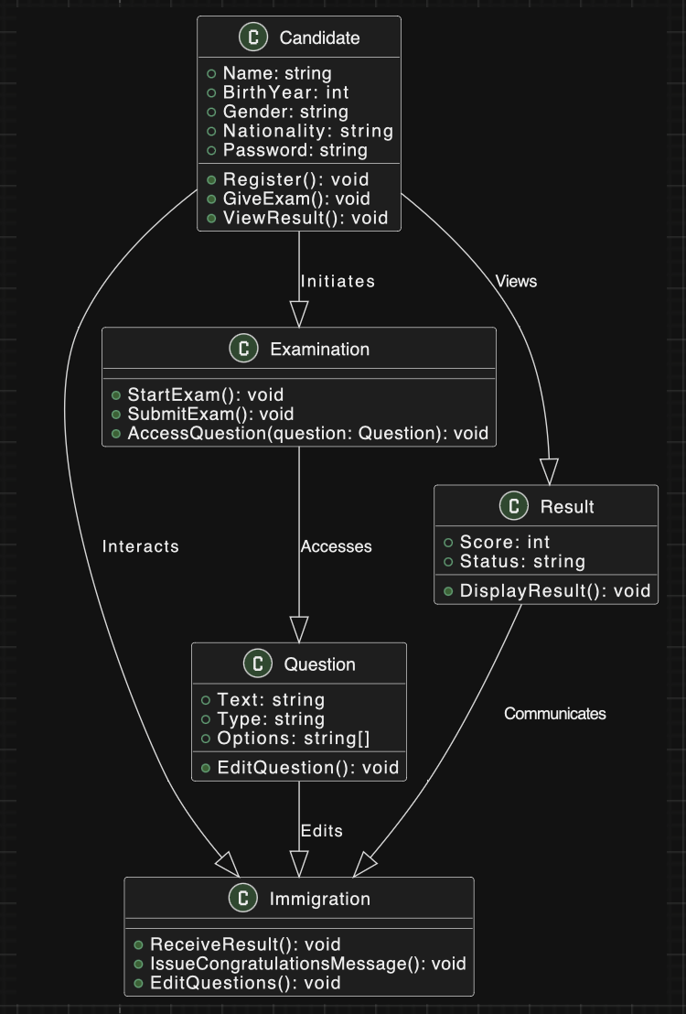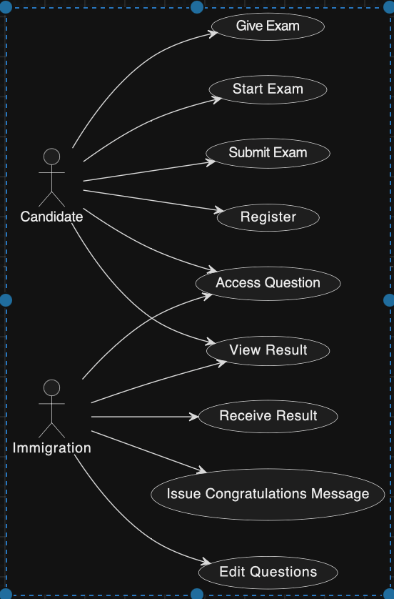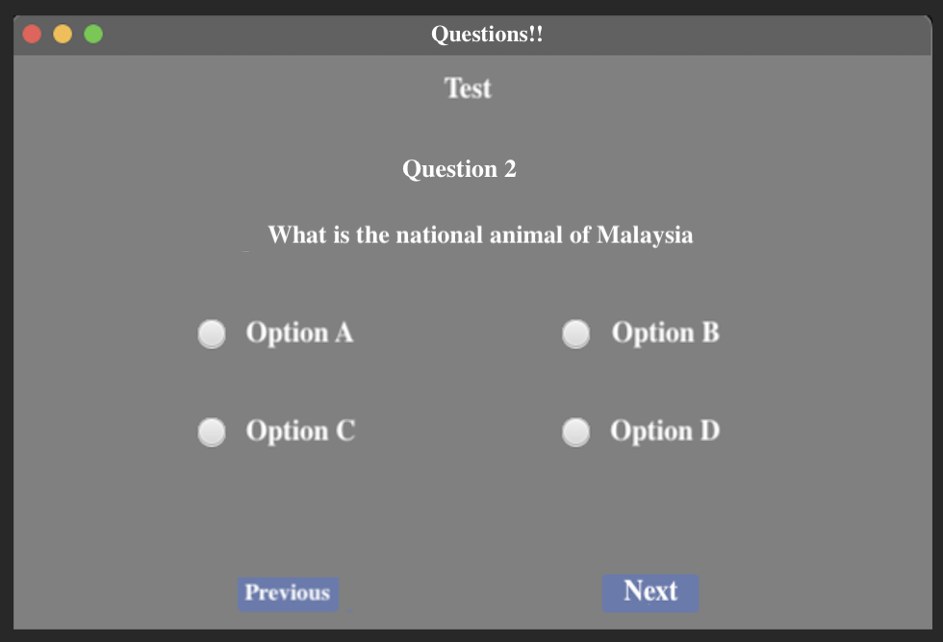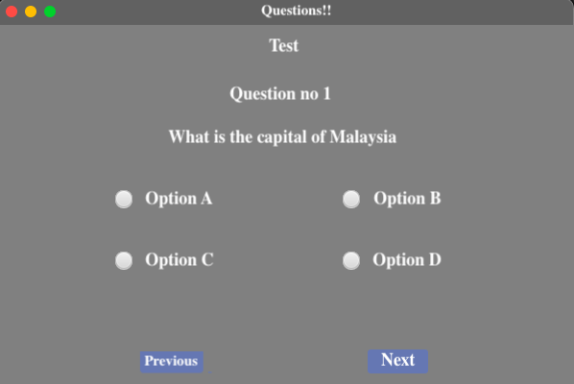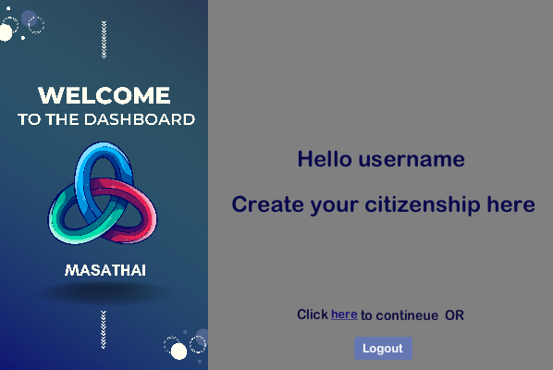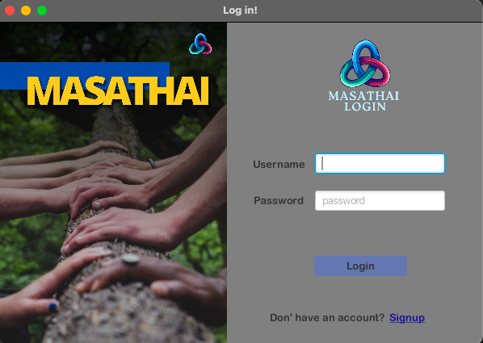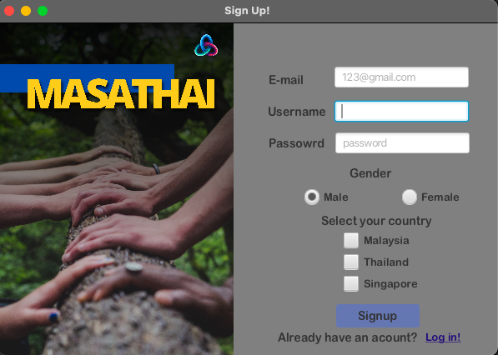

In conclusion, the document's purpose is to provide a comprehensive understanding of the problem statement, the system's objectives, and its significance in unifying Masathai while promoting informed citizenship. It will serve as a guide for the development team as they design and implement the Automated Citizenship Assessment System.